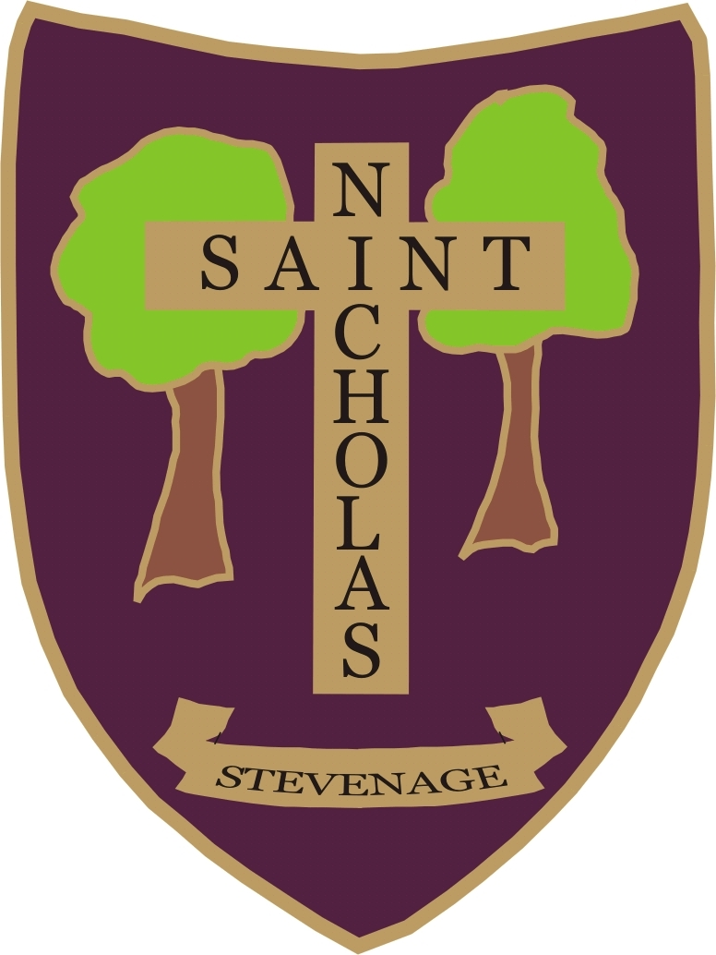 | Stevenage St Nicholas Primary School and Nursery  Learning, Living, Loving in God’s Family  SUPPLEMENTARY INFORMATION FORM 2025-26  If applying under categories 4, 5 or 6  Please complete in block capitals and  return this form to the School Office by 15th January 2025

Your Child’s Details

Name of Child ............................. .........................................................................................................

Date of Birth.....................................................................

Male / Female (Please delete as appropriate)

Your Details

Name of Parent or Carer...................................................................................................................

Permanent Home Address. (Note: This is the Child’s permanent residence and not an accommodation address.)

................................................................................................................................................................

................................................................................................ Post Code...............................................

Relationship to Child............................................. Home Telephone No. ................................................

Daytime Telephone No. ........................................ Mobile Phone No. ......................................................

In the event of over subscription, under which category of the Admissions Policy are you making this application?
Please refer to our Admissions Policy (Please tick appropriate box)
Children who have an EHC (Education, Health and Care) Plan which names this school will be admitted to the school before any oversubscription criteria are applied.

4: - Anglican

5: - Other Christian denominations

6: - Established world faiths – Please confirm which faith you are applying under.

Further Information

- If you applying under Category 4, 5 or 6 please have page 3 of this form confirming regular church/ place of worship attendance at least twice a month for the two years prior to this application being made completed and signed by your parish priest or religious leader as appropriate.

Please note that if the place of worship has been closed for public worship and has not provided alternative premises for that worship, the requirements of these admissions arrangements in relation to attendance will only apply to the period when the place of worship or alternative premises have been available for public worship.

Notes to parent

How the information on this form will be used:

By completing this form and signing the declaration below you are agreeing for St Nicholas School, if oversubscribed, to check whether your child’s details meet the school’s published admission rules and if he/she can be offered a school place.

Any personal data collected will be treated as confidential under the principles of the Data Protection Act 2018. We will not use the data for any other purpose, nor will we share your data with any third parties other than the Department for Education (for statutory reporting), Hertfordshire County Council departments who may from time to time send you advice, guidance and information relating to changes to early years provision and educational services that are relevant and/or of benefit to your child and your local children’s centre who support the local authority by assisting families to access the services that children are entitled to. We may use the church or religious places of worship information taken from the SIFs in order to facilitate communication between these establishments and our school.
We may retain the SIFs until the end of the academic year of admission.

DECLARATION
The information I have given on this form is complete and accurate. I understand that my personal information will be held securely and will be used only for the purpose of verifying this application.
I agree to St Nicholas School using this information to consider my application for a school place. I understand that if any part of this completed application form is found false the offer of a place may be withdrawn.
I understand that the completion of an application form does not guarantee a place in the school.

Signature of Parent or Carer....................................................... Full Name....................................................

Date.............................................

Thank you for completing this information. Please return to the school office by 15th January 2025

St Nicholas C of E (VA) Primary School and Nursery
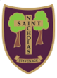

Six Hills Way, Stevenage, SG2 0PZ
Tel: 01438 352706, Email: admin@stnicholas120.herts.sch.uk Website: www.stnicholas120.herts.sch.uk
Headteacher: Mrs Lorraine Collins MA, BA (hons)

LETTER TO PRIEST OR RELIGIOUS LEADER

To Whom it may concern,

The Parent named on the form is applying for a place for their child at St Nicholas School.

In order for their child to be categorised as a church attendee we would be grateful if you could complete the attached Supplementary Information Form to support their application.

We may need to contact you to verify the information so please provide your contact details on the form.

Please note that if the place of worship has been closed for public worship and has not provided alternative premises for that worship, the requirements of these admissions arrangements in relation to attendance will only apply to the period when the place of worship or alternative premises have been available for public worship.

Thank you for your help with this.

Yours sincerely

Mrs L Collins
Headteacher

Learning, Loving, Living in God’s Family
“But I am like an olive tree flourishing in the house of God; I trust in God’s unfailing love forever and ever. Psalm 52:8
Stevenage St Nicholas Primary School and Nursery

SUPPLEMENTARY INFORMATION FORM FOR THOSE CLAIMING CHURCH ATTENDANCE

Clergy are asked to complete and sign this form to assist the Governors in ensuring that those most qualified for admission under Categories 4, 5 and 6 are properly considered. Please note that priority will be based on the parents’ or carers’ links with the church and not the child’s membership.

The relevant criteria, in priority order for the offering of places, are as follows: -

Category 4 Children of practising Anglicans, one or more of whose parents/carers have, at the time of application, shown commitment to the Church of England by worshipping at least twice a month for the two years immediately prior to an application being made. Applicants in this category are required to provide evidence in the relevant section of the SIF duly completed by their Parish Priest. Applicants in this category should note there is an expectation that the family will continue to attend church after admission to the school.

Category 5 Children from practising families of other Christian denominations, one or more of whose parents/carers have, at the time of application, shown commitment to that Place of Worship by attending at least twice a month for the two years immediately prior to an application being made. Applicants in this category are required to provide the relevant section of the SIF duly completed by their Priest, Minister or Pastor. Applicants in this category should note there is an expectation that the family will continue to attend church after admission to the school.

Category 6 Children from families of other established World Faiths whose parents/carers have, at the time of application, shown commitment to that place of worship by attending at least twice a month for the two years immediately prior to an application being made. Applicants in this category are required to provide the relevant section of the SIF duly completed by their religious leader. Applicants in this category should note there is an expectation that the family will continue to attend their place of worship after admission to the school.

Family Information

Name of Child in full....................................................................................................................................

Name of Parents or Carers..........................................................................................................................

Child’s Permanent Home Address.............................................................................................................

Church Information

Name and Denomination of Church or Other Faith’s place of worship...........................................................

Address...........................................................................................................................................................

…………………….………………………………………………………………………………………………………...

Name of Priest or Religious Leader.............................................................................................................................

Position in Church/ Place of worship..........................................Contact Telephone No. ......................................

If category 5, is this Church a member of Churches together in England or the Evangelical Alliance or who profess Trinitarian Faith?

YES / NO (Delete as appropriate).

I confirm that one or more parent/ carer has regularly worshipped at this Church/ attended this place of worship at least twice a month for a minimum of two years immediately prior to the date of this application.

Signature of Priest or Religious Leader.................................................................... Date..........................................

Please Print Name………………………………………………………………….

